User manual Erasmus ladder code / analysis.

All files needed to run the analysis:

* First version
* Final version
* All analysis
* SD calculator
* Double gaussian fits
* Python_lucas (folder)
* Excel file named sessions per group

In order to run this code we will need a functioning python IDE. If you do not have a python IDE installed yet we suggest you use Spyder via Anaconda (<https://www.anaconda.com/download>). Anaconda will contain a version of Spyder that already has some of the basics packages installed with it.

You might get some no module named … error in the beginning this can be resolved by typing !pip install (name of module) in the spyder console.

* 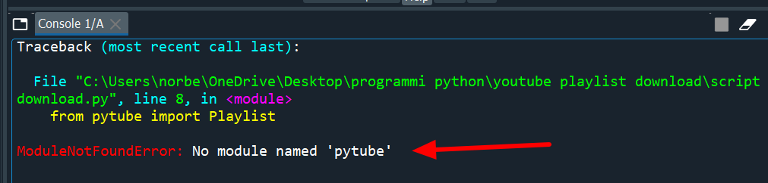
* Afbeelding met tekst, schermopname, Lettertype

  Automatisch gegenereerde beschrijving

Before we run the algorithm a choice has to be made. The Final_version.py uses filter settings that slightly vary between mice genotypes. For some mice genotypes the script contains these settings, if however your mice genotype is not part of this list you will have to run a couple of extra pyhton scripts to calculate these settings yourself.

**Calculating the settings manually**

The 2 settings we need in order to run the final_version script is the cut off runtime and the minimum touch time. To calculate these settings we first want to run the first_version.py script

To run the first_version script perform the following tasks

* Open the session_per_group excel file and add the session id’s of the mice group you want to analyze in a new column. Afbeelding met tekst, schermopname, nummer, Lettertype

  Automatisch gegenereerde beschrijving
* Open the first version script and go to line 42 of the code. Add your newly made column of mice and give them the same name as in the excel file (in our case manual). In line 46 and 47 add the name the mice group. Afbeelding met tekst, schermopname, Lettertype, software

  Automatisch gegenereerde beschrijving
* Now we have to make sure that the script is able to connect to your desired database. We do this by going to line 25 of the code and changing this to the location of the database on your device Afbeelding met tekst, schermopname, Lettertype

  Automatisch gegenereerde beschrijving
* Go to line 32 and change the code to match the location of the session_per_group excel file we altered earlier
* The final change we have to make is at the very end of the code to change the location of the output files of this script to match your desired output location. 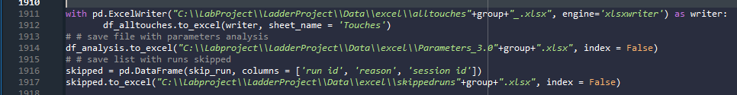
* Now we will use the SD calculator.py together with the output file parameters_3.0 to calculate the proper cut off runtime. We do this by opening the SD calculator.py and change in line 13 to match the location of the parameters file on your device and running the code.
* Then we will calculate the minimum touchtime by using the double gaussian fit script and the alltouches output file. Open the double gaussian fit script and change line 22 to match the output file location of the alltouches file and then run the code.
* The minimum runtime we want to use is the crossing of the 2 red lines.

**Without or after manually calculating the filter settings**

* Open the Final_version.py
* Add the manually entered filter settings into to script in line 168 by simply changing the minimum touchtime value and in line 102 in the following way. 
* Just like in the first version.py alter the file location of the database that contain the data aswell as the session_per_group file aswell as the base path, this is the location where the results will be saved. Afbeelding met tekst, Lettertype, schermopname

  Automatisch gegenereerde beschrijving
* Open the session_per_group excel file and add a column with session id’s of the mice you want to analyze (if you did this in the previous section to calculate the settings this step is redundant) Afbeelding met tekst, schermopname, nummer, Lettertype

  Automatisch gegenereerde beschrijving



* add the name of the mouse group you are testing (same name as in the excel file). Afbeelding met tekst, schermopname, Lettertype, software

  Automatisch gegenereerde beschrijving
* Add the same name to the group and group1 variable

* **You are now ready to run the final_version.py**

**After running the final_version.py**

* Change the first box of variables to match your data/device. The subject id’s are the id’s that are displayed in your database.Afbeelding met tekst, schermopname, software, Lettertype

  Automatisch gegenereerde beschrijving
* The base path folder should contain 2 groups of 4 excel files 1 group in the folder called mutant and another group in the folder called control (the names of the files/folder matter!, you can however manually alter this in the code if you want to change this).Afbeelding met tekst, software, Multimediasoftware, Lettertype

  Automatisch gegenereerde beschrijving
* Whatever you use as your base path out make 3 separate folders in this folder to account for the different stances for the heatmaps (RF LF means rightfront – leftfront)Afbeelding met tekst, schermopname, software, Lettertype

  Automatisch gegenereerde beschrijving
* The only other thing that you might want to alter is the color scheme for the PCA. This line of code assigns a color to each session so session 1 of the WT is the first color session 2 the second color etc.